***LEVEL -1***

***TASK -1***

* Create a simple webpage with a heading, paragraph, and image using

HTML and CSS.

<!DOCTYPE html>

<html lang="en">

<head>

<meta charset="UTF-8">

<meta name="viewport" content="width=device-width, initial-scale=1.0">

<title>Simple Webpage</title>

<style>

body {

font-family: Arial, sans-serif;

margin: 0;

padding: 0;

background: #f4f4f4;

}

.container {

width: 80%;

margin: auto;

overflow: hidden;

}

header {

background: #50b3a2;

color: white;

padding-top: 30px;

min-height: 70px;

border-bottom: #e8491d 3px solid;

}

header a {

color: #ffffff;

text-decoration: none;

text-transform: uppercase;

font-size: 16px;

}

header ul {

padding: 0;

list-style: none;

}

header li {

display: inline;

margin: 0 20px;

}

header #branding {

float: left;

}

header #branding h1 {

margin: 0;

}

header nav {

float: right;

margin-top: 10px;

}

header .highlight, header .current a {

color: #e8491d;

font-weight: bold;

}

header a:hover {

color: #ffffff;

font-weight: bold;

}

.content {

padding: 20px;

background: #ffffff;

margin-bottom: 20px;

}

.content img {

max-width: 100%;

height: auto;

}

</style>

</head>

<body>

<header>

<div class="container">

<div id="branding">

<h1>Simple Webpage</h1>

</div>

<nav>

<ul>

<li class="current"><a href="#">Home</a></li>

<li><a href="#">About</a></li>

<li><a href="#">Services</a></li>

</ul>

</nav>

</div>

</header>

<section class="content">

<div class="container">

<h2>Welcome to the Simple Webpage</h2>

<p>This is a web page with a heading, a paragraph, and an image. It's is created using HTML and styled using basic CSS. This page contains image of APSHCE logo.</p>

<img src="https://tse4.mm.bing.net/th?id=OIP.Ij8UeJYbflvVd1sMEqizrAHaHa&pid=Api&P=0&h=180">

</div>

</section>

</body>

</html>

***OUTPUT –***

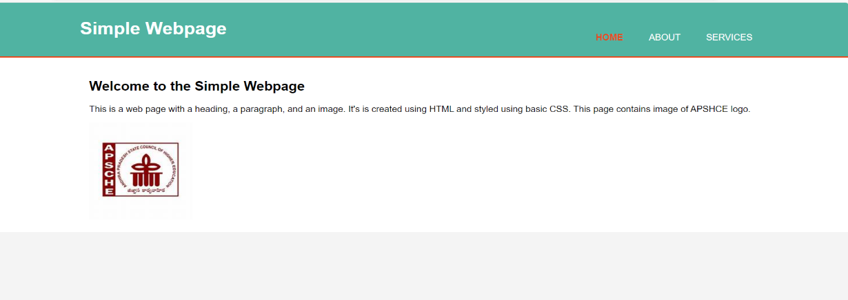

* Build a basic form with a single input field and a submit button using

HTML and CSS.

<!DOCTYPE html>

<html>

<body>

<h2>HTML Forms</h2>

<form action="/action_page.php">

<label for="fname">First name:</label><br>

<input type="text" id="fname" name="fname" value="John"><br>

<label for="lname">Last name:</label><br>

<input type="text" id="lname" name="lname" value="Doe"><br><br>

<input type="submit" value="Submit">

</form>

<p>If you click the "Submit" button, the form-data will be sent to a page called "/action_page.php".</p>

</body>

</html>

***OUTPUT –***

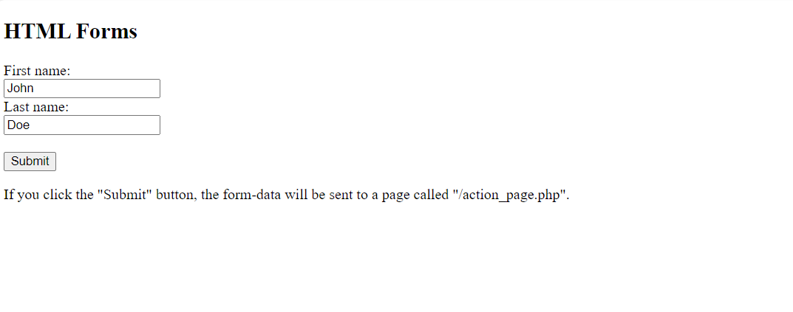

* Design and code a simple navigation menu with three links using

HTML and CSS.

<!DOCTYPE html>

<html lang="en">

<head>

<meta charset="UTF-8">

<meta name="viewport" content="width=device-width, initial-scale=1.0">

<title>Simple Navigation Menu</title>

<style>

/* Reset the padding and margin to remove default browser styling */

body, ul {

margin: 0;

padding: 0;

}

/* Style the navigation bar */

.navbar {

background-color: #333;

overflow: hidden; /* Ensures the navbar contains floated elements */

list-style-type: none; /* Remove bullet points from the list */

}

/* Style the navigation links */

.navbar li {

float: left; /* Float the list items to be in line */

}

.navbar li a {

display: block; /* Change the display to block for styling */

color: white; /* Text color */

text-align: center; /* Center the text */

padding: 14px 20px; /* Add padding for spacing */

text-decoration: none; /* Remove underlines from links */

}

/* Change the color of links on hover */

.navbar li a:hover {

background-color: #ddd;

color: black;

}

/* Style for the active/current link */

.navbar li a.active {

background-color: #4CAF50;

color: white;

}

</style>

</head>

<body>

<!-- Navigation menu -->

<ul class="navbar">

<li><a class="active" href="#home">Home</a></li>

<li><a href="#about">About</a></li>

<li><a href="#contact">Contact</a></li>

</ul>

</body>

</html>

***OUTPUT –***



***TASK -2***

* Develop a basic button that changes its colour when clicked using JavaScript.

<!DOCTYPE html>

<html lang="en">

<head>

<meta charset="UTF-8">

<meta name="viewport" content="width=device-width, initial-scale=1.0">

<title>Button Color Change</title>

<style>

.color-change-button {

padding: 10px 20px;

font-size: 16px;

color: white;

background-color: #007bff;

border: none;

border-radius: 5px;

cursor: pointer;

outline: none;

}

/* Optional: Adding a hover effect to the button */

.color-change-button:hover {

opacity: 0.8;

}

</style>

</head>

<body>

<button class="color-change-button" id="changeColorButton">Click me!</button>

<script>

// Function to generate a random color

function getRandomColor() {

var letters = '0123456789ABCDEF';

var color = '#';

for (var i = 0; i < 6; i++) {

color += letters[Math.floor(Math.random() * 16)];

}

return color;

}

// Function to change the color of the button

function changeButtonColor() {

var newColor = getRandomColor();

document.getElementById('changeColorButton').style.backgroundColor = newColor;

}

// Add event listener to the button

document.getElementById('changeColorButton').addEventListener('click', changeButtonColor);

</script>

</body>

</html>

***OUTPUT –***

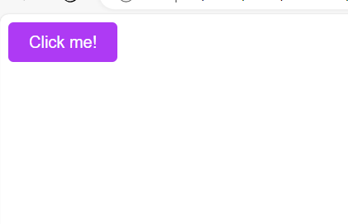

* Create an alert box that displays a greeting message based on the current time using JavaScript.

<!DOCTYPE html>

<html lang="en">

<head>

<meta charset="UTF-8">

<meta name="viewport" content="width=device-width, initial-scale=1.0">

<title>Greeting Based on Time</title>

</head>

<body>

<script>

function getGreetingBasedOnTime() {

var currentTime = new Date();

var hour = currentTime.getHours();

var greeting;

if (hour < 12) {

greeting = "Good morning!";

} else if (hour < 18) {

greeting = "Good afternoon!";

} else {

greeting = "Good evening!";

}

return greeting;

}

// Show an alert box with the greeting message

alert(getGreetingBasedOnTime());

</script>

</body>

</html>

***OUTPUT –***



* Build a basic calculator that adds two numbers together and displays the result using JavaScript.

<!DOCTYPE html>

<html lang="en">

<head>

<meta charset="UTF-8">

<meta name="viewport" content="width=device-width, initial-scale=1.0">

<title>Basic Calculator</title>

</head>

<body>

<!-- Calculator form -->

<form id="calculator">

<input type="number" id="number1" placeholder="Enter first number" required>

<input type="number" id="number2" placeholder="Enter second number" required>

<input type="button" value="Add" onclick="addNumbers()">

</form>

<!-- Result display -->

<p id="result"></p>

<script>

function addNumbers() {

// Get values from input fields

var num1 = parseFloat(document.getElementById('number1').value);

var num2 = parseFloat(document.getElementById('number2').value);

// Calculate the sum

var sum = num1 + num2;

// Display the result

document.getElementById('result').innerText = 'Result: ' + sum;

}

</script>

</body>

</html>

***OUTPUT –***

